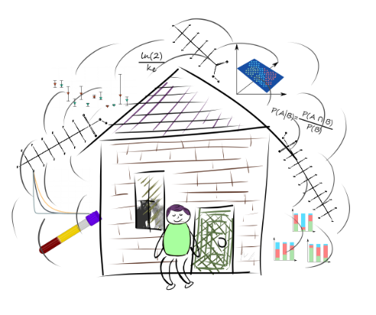Dylan J. Wallis

|  |  |  |
| --- | --- | --- |
| Raleigh, NC | (727) 439-3631 | wallis.dylan@epa.gov |

|  |  |  |  |  |  |  |  |  |  |
| --- | --- | --- | --- | --- | --- | --- | --- | --- | --- |
| Relevant Experience |  | |  | |  | Skills | |  | |
| 2022-Present |  | | I In this role I use advanced statistical techniques to analyze data from **human health studies**. I examine factors influencing exposure and health outcomes. I Review scientific literature on the **impacts** of PFAS exposure and **the social determinants of health**. I also lead the planning and implementation of exposure studies and examine **large datasets**. I am able to present research findings at conferences, publish peer-reviewed papers, and engage in informal discussions with colleagues and superiors to communicate my findings. |  |  | | Analyzing Big Data | |
| ORISE Post-doctoral Fellow |  |  |  |  |  | | Statistical Techniques | |
| EPA: Dr. Jeffery Minucci |  |  |  |  |  | | Data Visualization | |
|  |  |  |  |  |  | | Coding in R, Python, SAS, Bash, LATEX | |
|  |  |  |  |  |  | | Source Apportionment | |
|  |  |  |  |  |  | | Experimental Design and Execution | |
|  |  |  |  |  |  | |  | |
|  |  |  |  |  |  | |  | |
|  |  |  |  |  |  | |  | |
| 2018-2022 |  | | In this position I used bioinformatic, biological, and biochemical techniques to identify **gene-environment interactions** affecting vulnerability to exposure with zebrafish in a high-throughput assay. I mentored student by helping in design and execution of research projects and grants. I also assisted in organizing and performing field collections for a **human health and exposure study** and estimated the toxicokinetics of novel compounds. To fund my research, I planned and wrote multiple federal grants. Unlike many statisticians I designed **bench-lab experiments** and developed **bioinformatic pipelines myself**. To communicate research findings, I presented at conferences and meetings, wrote papers, spoke at public meetings, and discussed my research in informal gatherings. |  |  | | Standard Wet-lab Techniques | |
| Research Assistant |  |  |  |  |  | | Statistical Modeling | |
| NCSU: Dr. David Reif |  |  |  |  |  | | Machine Learning | |
|  |  |  |  |  |  | | Insect Model Organisms | |
|  |  |  |  |  |  | | Toxicokinetics | |
|  |  |  |  |  |  | | | |
|  |  |  |  |  | Awards | | | |
|  |  |  |  |  | *3rd place*North Carolina Society of Toxicology Graduate Student Presentation Award | | | |
|  |  |  |  |  | Summer Institute of Statistical Genetics Scholarship | | | |
|  |  |  |  |  | AAAS/Science Program for Excellence in Science | | | |
|  |  |  |  |  | ACS Division of Analytical Chemistry Award | | | |
| 2016-2018 |  | | During undergrad I used biochemistry and computational biology techniques to study **fatty acid synthesis**, **lipidomics** and **signaling** in insect models |  |  | | | |
| Research Assistant |  |  |  |  | [Qr code  AI-generated content may be incorrect.https://www.dylandoesscience.com/](https://www.dylandoesscience.com/) | | | |
| USF: Dr. David Merkler |  |  |  |  |  | | | |
| Education |  |  |  |  |  | | | |
| 2018-2022 |  | | Ph.D. Toxicology |  |  | | | |
| North Carolina State University |  |  | Dissertation: The Many Layers of Toxicology: a Multi-Layered Approach to Understanding Exposure and Vulnerability |  |  | | | |
| 2014-2018 |  | | B.S. Chemistry |  |  | | | |
| University of South Florida |  |  | B.S Cell and Molecular Biology |  |  | | | |